**Assignment-1: Warm-up with python**

**Ans**

1)python

2)

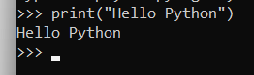

3)



4)

print("Hello Python")

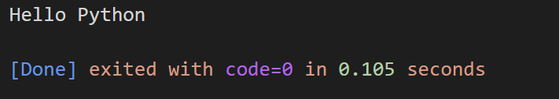

5)

print("Hello \nPython")

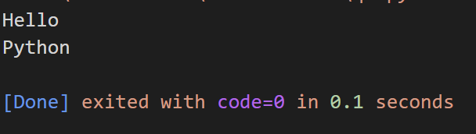

6) print("\"MySirG\"")

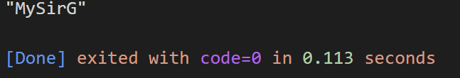

7) print("\"Teacher's Day\"")

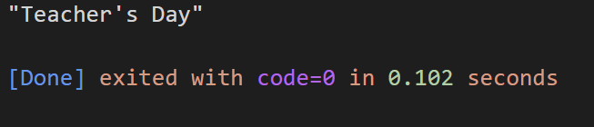

8) name= "Saumya Ranjan Mohapatra"

print("NAME:-", name)

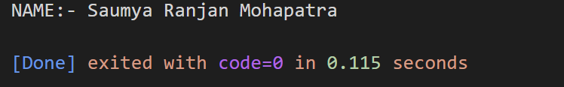

9) name = "Saumya"

age = 20

qualification ="BCA"

yoe = 0

print ("My name is",name,"and my age is ",age,"i am doing my graduation in ",qualification,"and i have ",yoe ,"of yoe")



10) x = 10

y = 20

z = 30

print(x,"\n",y,"\n",z)

